**Ben Brandhorst**

**November 15th 2019**

**Database Security**

**SDEV 350 7980**

**Professor Ivan De Los Santos**

**LAB 3 – Creating Profiles, Users and Roles**

**Test Plan U1BenBrandhorst**

|  |  |  |  |
| --- | --- | --- | --- |
| **INPUT** | **EXPECTED OUTPUT** | **ACTUAL OUTPUT** | **PASS??** |
| CREATE TABLE U1Example  (  U1EID NUMBER NOT NULL,  Lastname VARCHAR2(50) NOT NULL,  Firstname VARCHAR2(50) NOT NULL,  Email VARCHAR2(254) NOT NULL,  CONSTRAINT U1Example_pk PRIMARY KEY(U1EID)  ); | Table U1EXAMPLE created. | Table U1EXAMPLE created. | YES |
| SELECT U1ID FROM BBRANDHORST.user1data; | U1ID  ----------  1  2  3 | U1ID  ----------  1  2  3 | YES |
| INSERT INTO BBRANDHORST.user1data VALUES (4, 'Smith', 'Adam', 'Adam.Smith@email.com'); | 1 row inserted. | 1 row inserted. | YES |
| SELECT U2ID FROM BBRANDHORST.user2data; | SQL Error: ORA-00942: table or view does not exist | SQL Error: ORA-00942: table or view does not exist | YES |
| INSERT INTO BBRANDHORST.User2Data VALUES (4, 'Ruth', 'Babe', 'Babe.Ruth@email.com'); | SQL Error: ORA-00942: table or view does not exist | SQL Error: ORA-00942: table or view does not exist | YES |
| DROP TABLE BBrandhorst.User1Data; | Error report -  ORA-01031: insufficient privileges | Error report -  ORA-01031: insufficient privileges | YES |
| DROP TABLE BBrandhorst.User2Data; | Error report -  ORA-00942: table or view does not exist | Error report -  ORA-00942: table or view does not exist | YES |

**Figure 1 – (U1BenBrandhorst Password Reset) This is a screen capture showing the password reset for U1BenBrandhorst.**

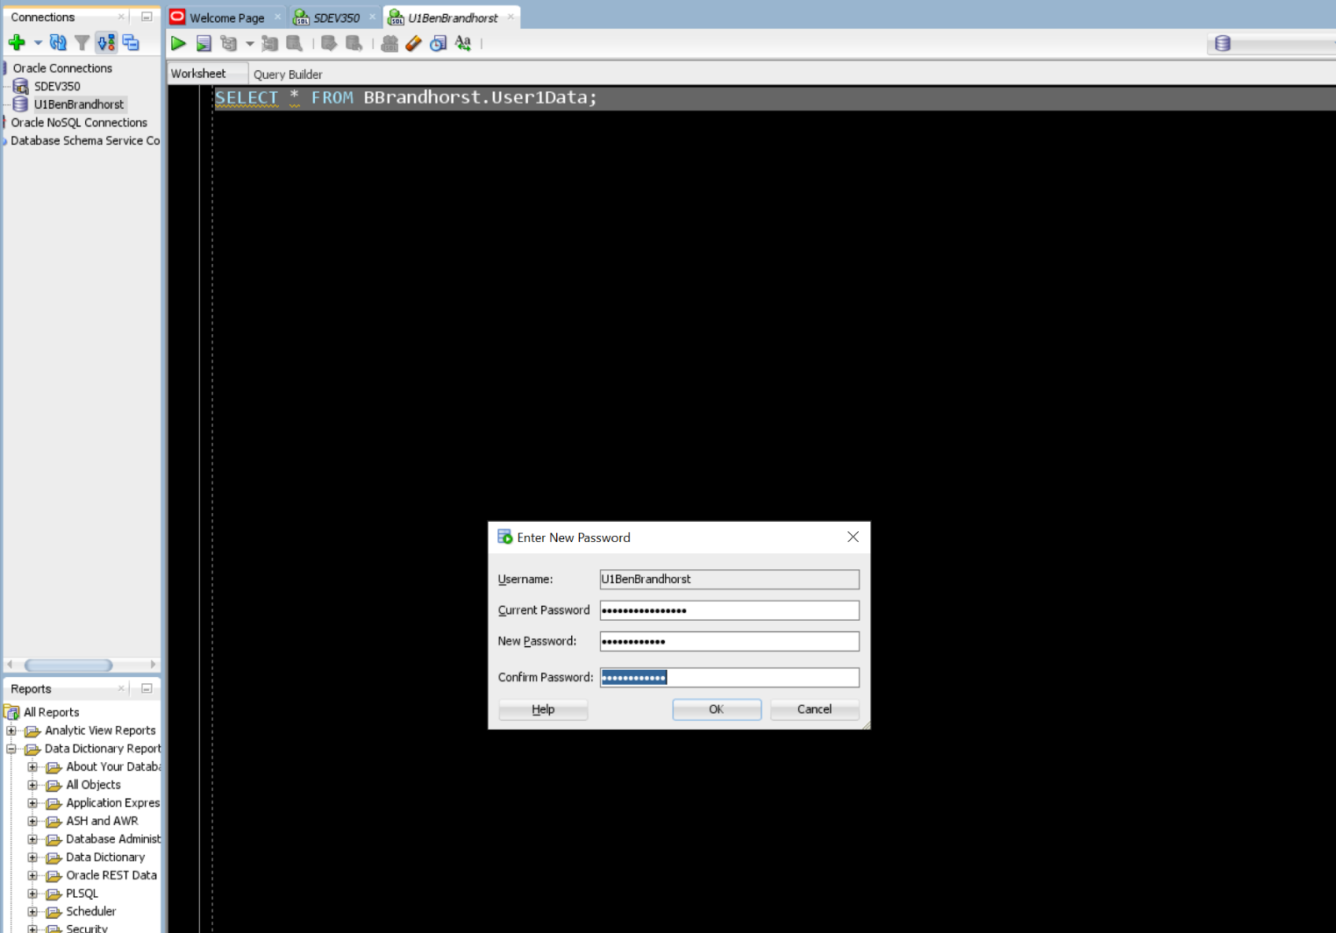

**Figure 2 – (Create U1Example Table) Here U1BenBrandhorst demonstrates his ability to create a simple table.**

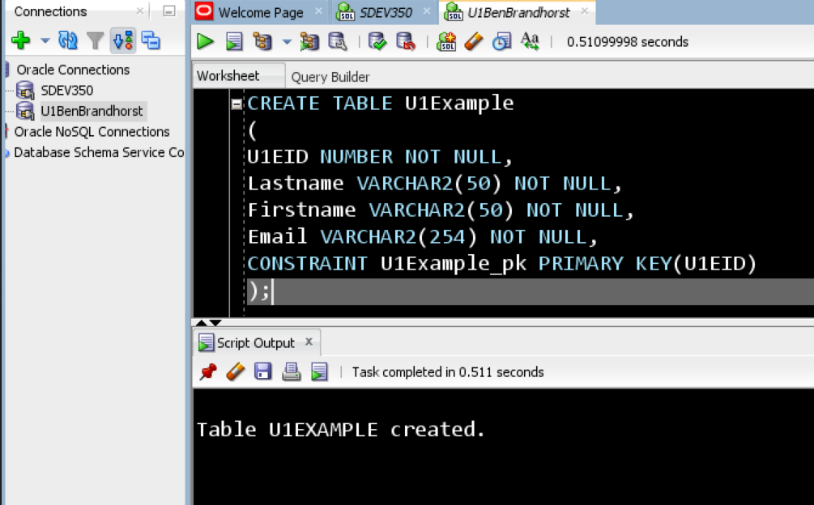

**Figure 3 – (SELECT U1ID) Here U1BenBrandhorst shows the User has rights to SELECT from the User1Data table.**

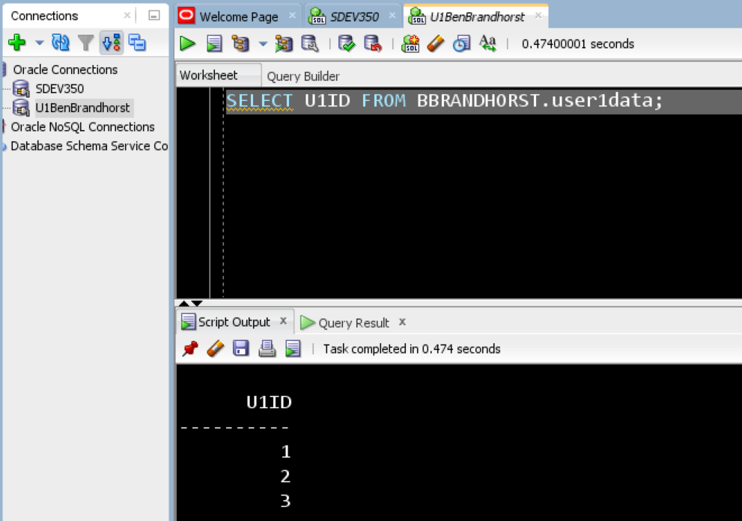

**Figure 4 – (INSERT INTO User1Data) Here U1BenBrandhorst shows the User has rights to insert records into the User1Data table.**

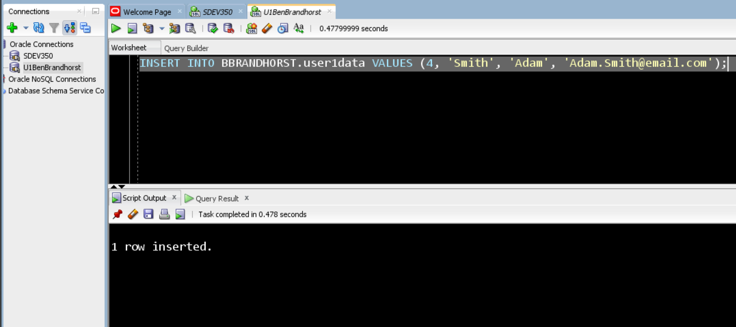

**Figure 5 – (SELECT U2ID) Here U1BenBrandhorst shows the User does not have rights to select records from the User2Data table.**

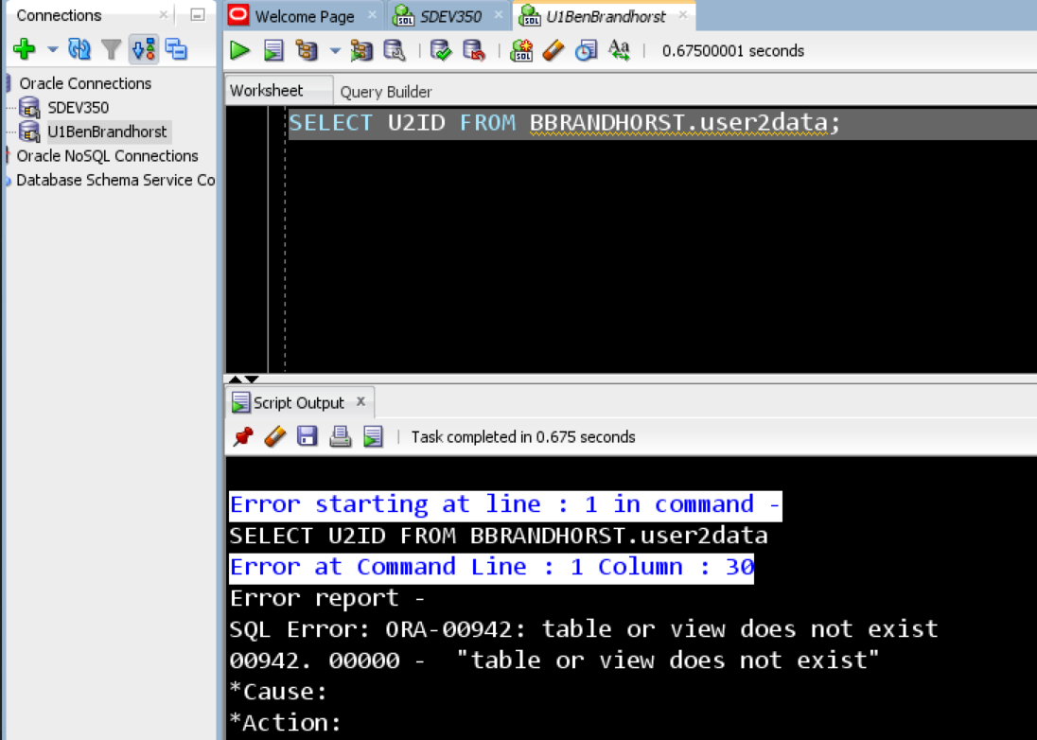

**Figure 6 – (INSERT INTO User2Data) Here U1BenBrandhorst shows the User does not have any rights associated with the User2Data table. The database will not confirm the existence of the table to the user and no records can be inserted.**

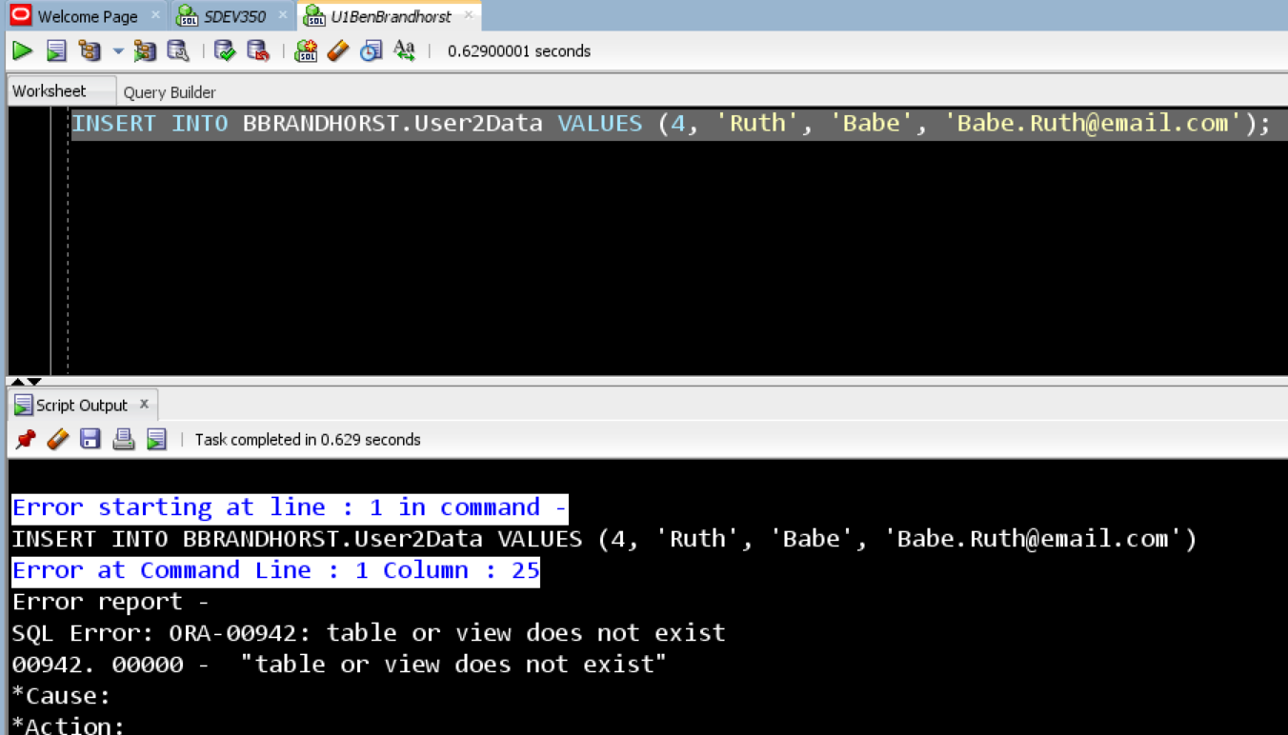

**Figure 7 – (DROP TABLE User1Data) Here U1BenBrandhorst shows the User does not have rights to drop the User1Data table.**

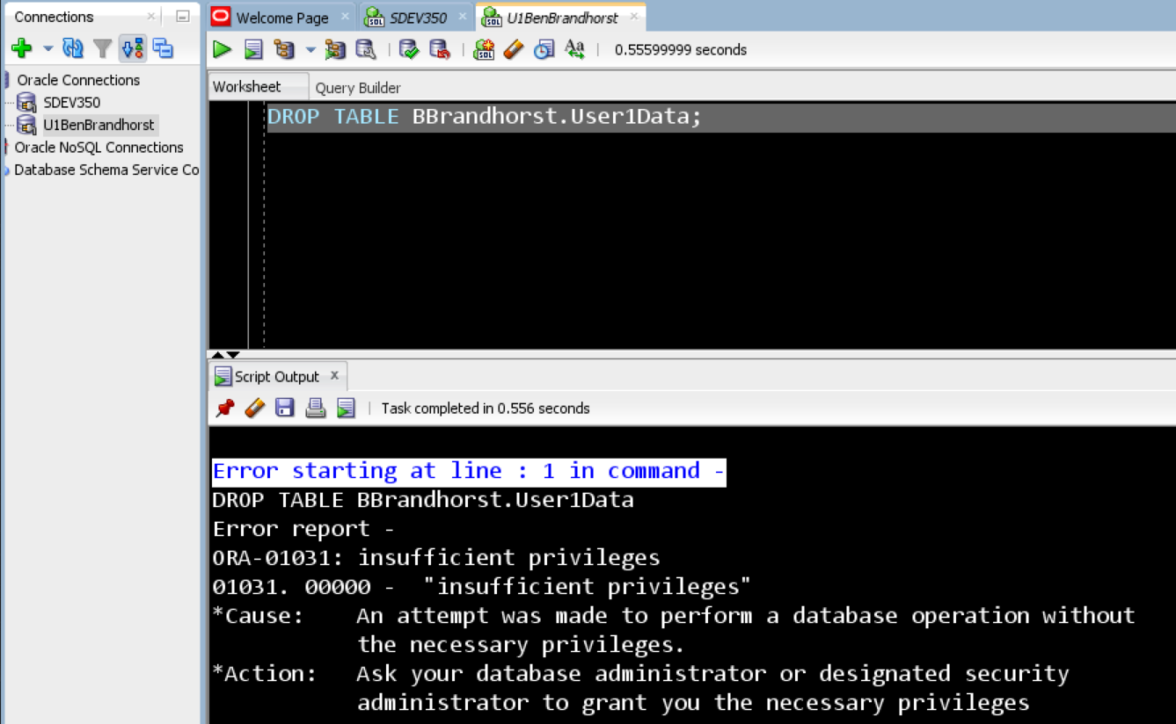

**Figure 8 – (DROP TABLE User2Data) Here U1BenBrandhorst shows the User does not have any rights associated with User2Data and cannot even see, let alone drop the table.**

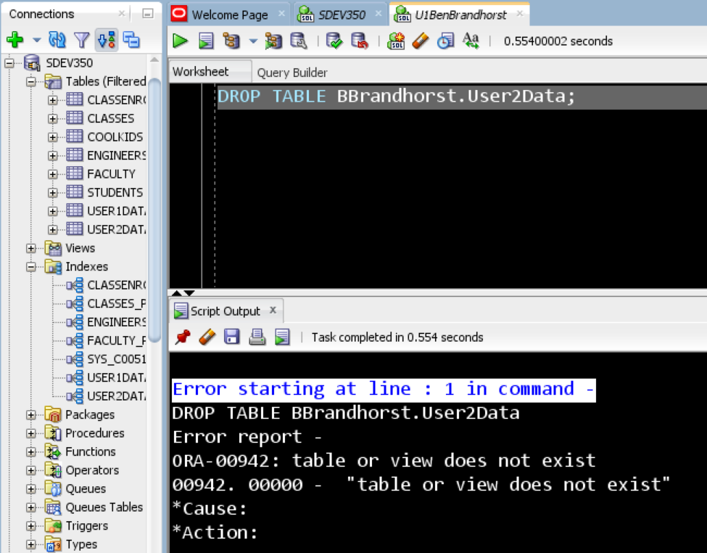

**Test Plan U2BenBrandhorst**

|  |  |  |  |
| --- | --- | --- | --- |
| **INPUT** | **EXPECTED OUTPUT** | **ACTUAL OUTPUT** | **PASS??** |
| CREATE TABLE U2Example  (  U2EID NUMBER NOT NULL,  Lastname VARCHAR2(50) NOT NULL,  Firstname VARCHAR2(50) NOT NULL,  Email VARCHAR2(254) NOT NULL,  CONSTRAINT U2Example_pk PRIMARY KEY(U2EID)  ); | Table U2EXAMPLE created. | Table U2EXAMPLE created. | YES |
| SELECT U1ID FROM BBRANDHORST.user1data; | U1ID  ----------  1  2  3  4 | U1ID  ----------  1  2  3  4 | YES |
| INSERT INTO BBRANDHORST.User1Data VALUES (5, 'Garcia', 'Jerry', 'Jerry.Garcia@email.com'); | Error report -  SQL Error: ORA-01031: insufficient privileges | Error report -  SQL Error: ORA-01031: insufficient privileges | YES |
| SELECT U2ID FROM BBRANDHORST.user2data; | U2ID  ----------  1  2  3 | SQL Error: ORA-00942: table or view does not exist | YES |
| INSERT INTO BBRANDHORST.User2Data VALUES (4, 'Ruth', 'Babe', 'Babe.Ruth@email.com'); | Error report -  SQL Error: ORA-01031: insufficient privileges | Error report -  SQL Error: ORA-01031: insufficient privileges | YES |
| DROP TABLE BBrandhorst.User1Data; | Error report -  ORA-01031: insufficient privileges | Error report -  ORA-01031: insufficient privileges | YES |
| DROP TABLE BBrandhorst.User2Data; | Error report -  ORA-00942: table or view does not exist | Error report -  ORA-00942: table or view does not exist | YES |

**Figure 9 – (U2BenBrandhorst Password Reset) This is a screen capture showing the password reset for U2BenBrandhorst.**

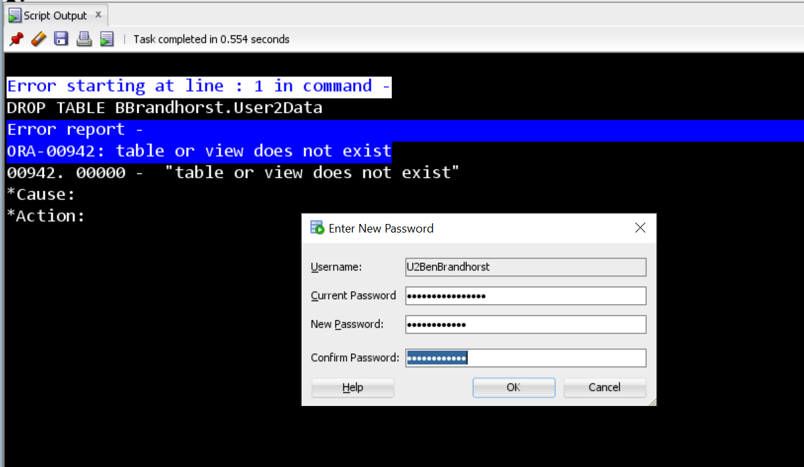

**Figure 10 – (Create U2Example Table) Here U2BenBrandhorst demonstrates his ability to create a simple table.**

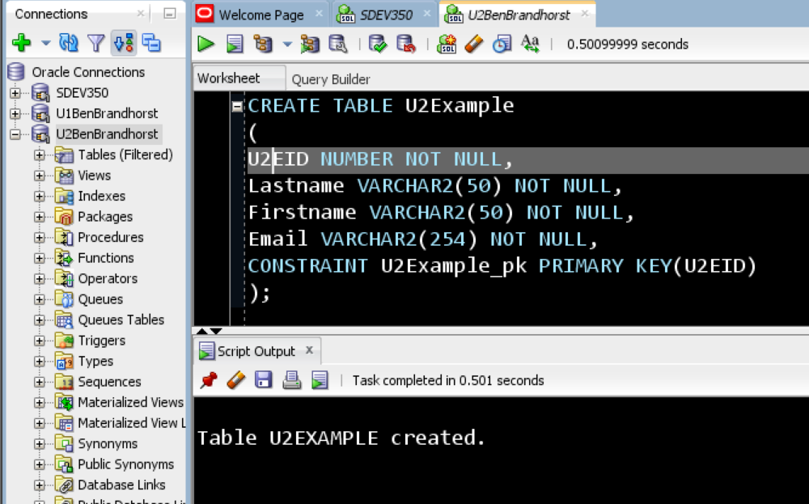

**Figure 11 – (SELECT U1ID) Here U2BenBrandhorst shows the User has rights to SELECT from the User1Data table.**

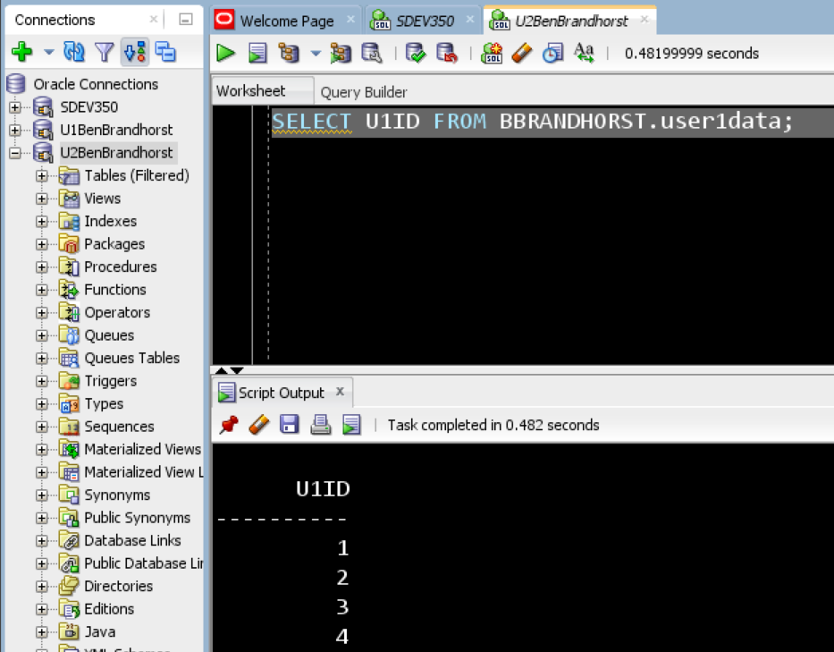

**Figure 12 – (INSERT INTO User1Data) Here U2BenBrandhorst shows the User does not have rights to insert records into the User1Data table.**

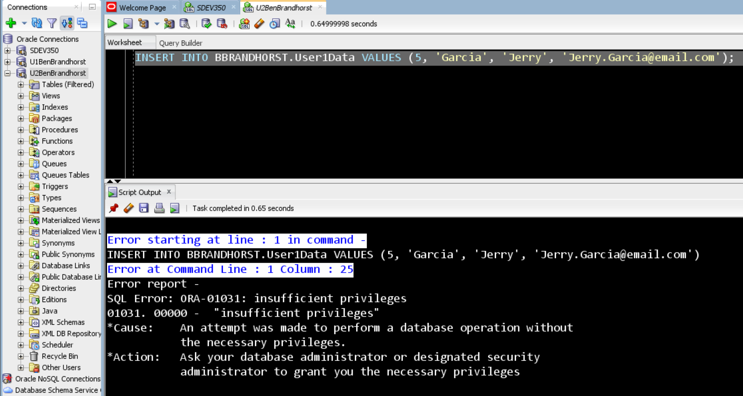

**Figure 13 – (SELECT U2ID) Here U2BenBrandhorst shows the User has rights to select records from the User2Data table.**

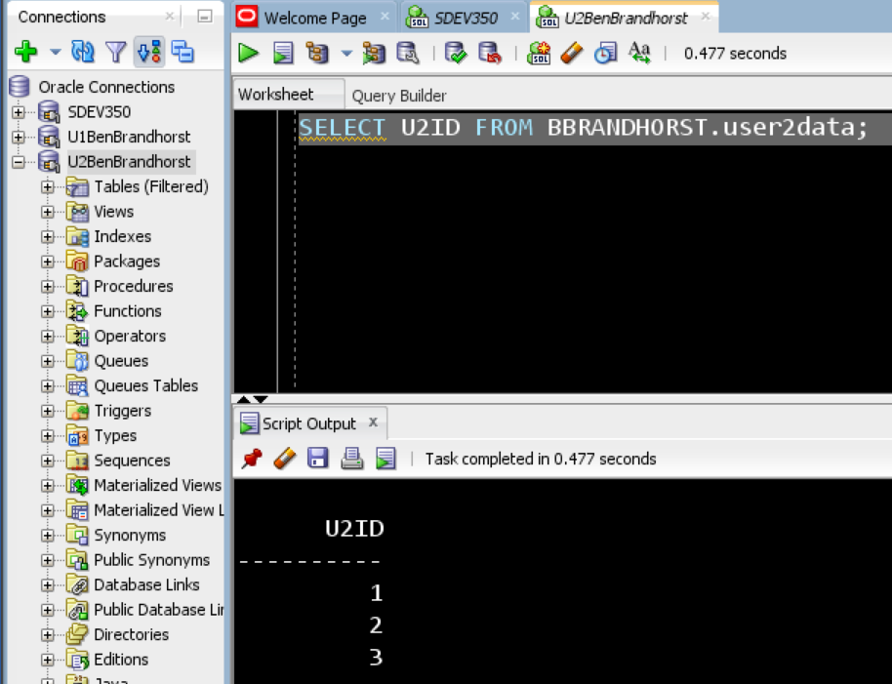

**Figure 14 – (INSERT INTO User2Data) Here U2BenBrandhorst shows the User does not rights to insert data into the User2Data table.**

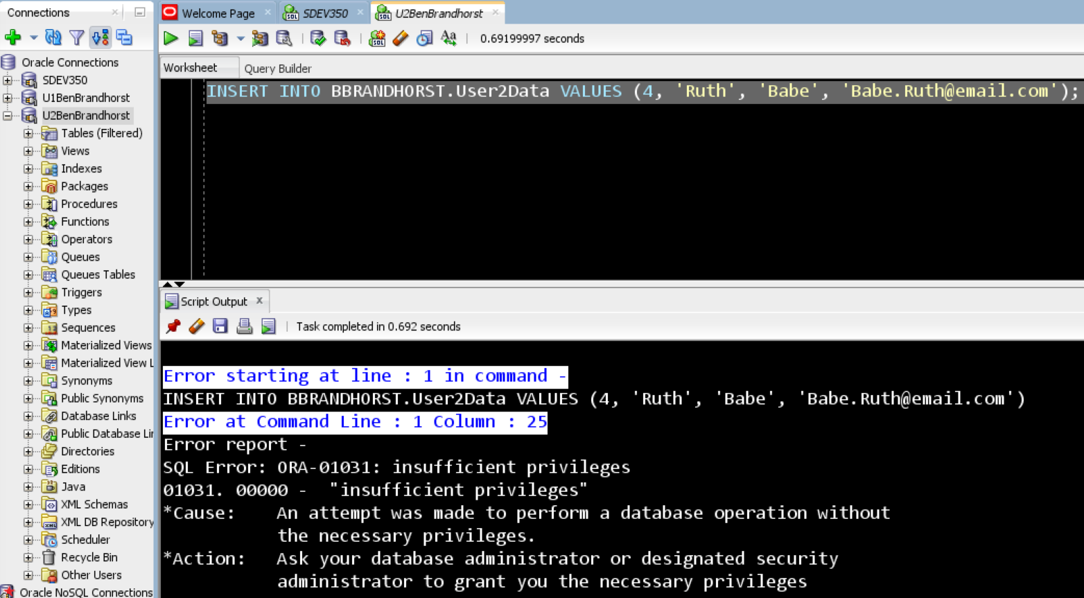

**Figure 15 – (DROP TABLE User1Data) Here U2BenBrandhorst shows the User does not have rights to drop the User1Data table.**

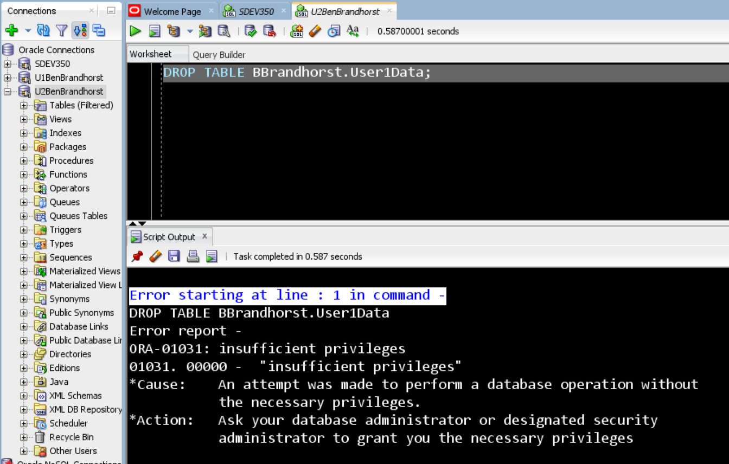

**Figure 16 – (DROP TABLE User2Data) Here U2BenBrandhorst shows the User does not have the rights to drop the User2Data table.**

